Lecture#25 Provider
Objectives
- Provider
- Counter App using provider

Provider:
- Provider is a Flutter package that makes it easy to manage app state and share data between different parts of the app.
- It is a simple, yet powerful way to manage state in Flutter apps without having to use complex patterns like Redux or MobX.
- How to use Provider?
- To use Provider, you need to first add the package to your project by adding the following line to your pubspec.yaml file:
dependencies:
provider: ^6.0.0
- Once you have added the package, you can start using it in your app by creating a provider. Providers can be created using different types, such as ChangeNotifierProvider, FutureProvider, StreamProvider, and more.
- Here's an example of how to create a ChangeNotifierProvider:
ChangeNotifierProvider(
create: (context) => MyModel(),
child: MyApp(),
)
- Using Provider to access state
- Once you have created a provider, you can access its state using the Provider.of method.
- For example, if you have a ChangeNotifierProvider with a MyModel instance, you can access the state like this:
MyModel model = Provider.of<MyModel>(context);

Simple Counter Example using provider:
import 'package:flutter/material.dart';
import 'package:provider/provider.dart';

void main() {
runApp(MyApp());
}

class CounterModel extends ChangeNotifier {
int _counter = 0;

int get counter => _counter;

void incrementCounter() {
_counter++;
notifyListeners();
}
}

class MyApp extends StatelessWidget {
@override
Widget build(BuildContext context) {
return MultiProvider(
providers: [
ChangeNotifierProvider(create: (_) => CounterModel()),
],
child: MaterialApp(
title: 'Flutter MultiProvider Example',
home: HomeScreen(),
),
);
}
}

class HomeScreen extends StatelessWidget {
@override
Widget build(BuildContext context) {
return Scaffold(
appBar: AppBar(
title: Text('Counter App'),
),
body: Center(
child: Consumer<CounterModel>(
builder: (context, counterModel, child) => Text(
'Counter: ${counterModel.counter}',
style: TextStyle(fontSize: 24.0),
),
),
),
floatingActionButton: FloatingActionButton(
onPressed: () {
Provider.of<CounterModel>(context, listen: false).incrementCounter();
},
child: Icon(Icons.add),
),
);
}
}

Screenshot:
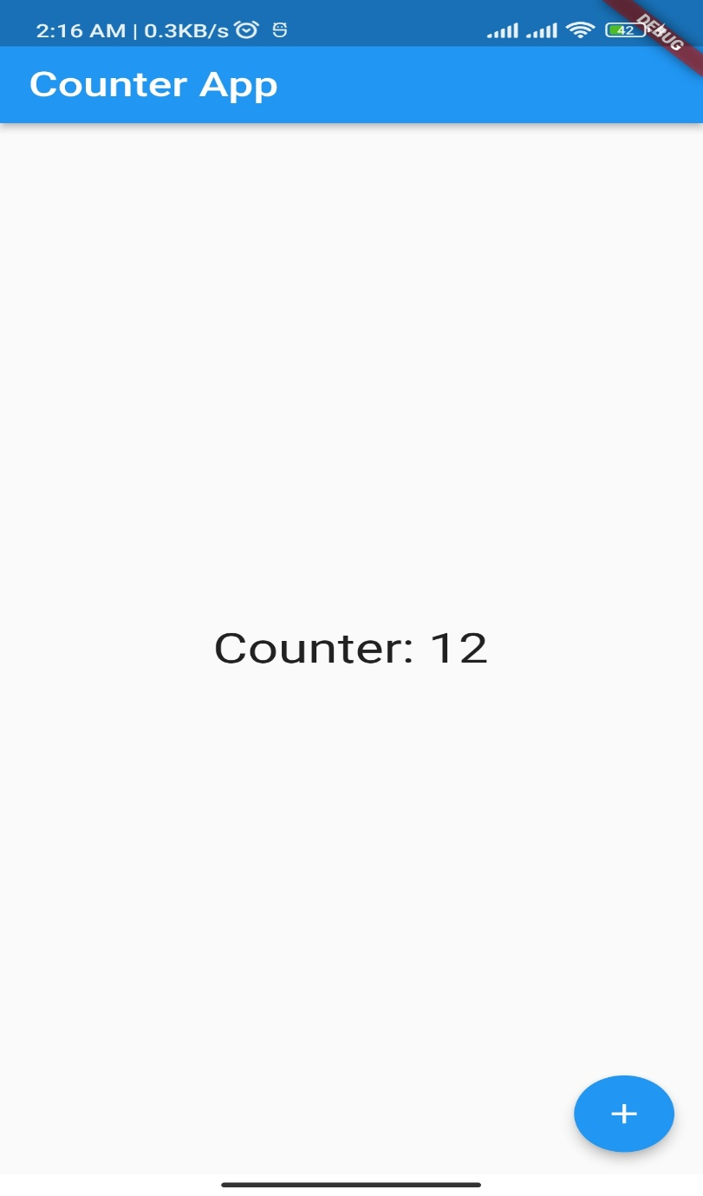

Lecture#26 List with Provider
Objectives
- Flutter Provider with List
- Todo List Example using provider

Provider with List
- Define your model: In this example, we'll create a simple Item class with a name and a price:
class Item {
final String name;
final double price;

Item(this.name, this.price);
}
- Create a Provider: We'll create a Provider for a list of Item objects using the ChangeNotifierProvider class:
ChangeNotifierProvider<List<Item>>(
create: (_) => [],
),
- Access the Provider: To display the list of items, we'll use the Consumer widget to listen for changes to the list:
Consumer<List<Item>>(
builder: (context, items, child) {
return ListView.builder(
itemCount: items.length,
itemBuilder: (context, index) {
final item = items[index];
return ListTile(
title: Text(item.name),
subtitle: Text('\$${item.price.toStringAsFixed(2)}'),
);
},
);
},
),

Todo List Example:
Model class

class Todo {
final String title;
bool isDone;

Todo({
required this.title,
this.isDone = false,
});

void toggleDone() {
isDone = !isDone;
}
}

import 'package:flutter/material.dart';
import 'package:provider/provider.dart';

void main() {
runApp(MyApp());
}

class MyApp extends StatelessWidget {
@override
Widget build(BuildContext context) {
return ChangeNotifierProvider(
create: (context) => TodoList(),
child: MaterialApp(
title: 'Todo List',
home: TodoListScreen(),
),
);
}
}
Provider class

class TodoList extends ChangeNotifier {
List<Todo> _todos = [
Todo(title: 'Buy milk'),
Todo(title: 'Buy eggs'),
Todo(title: 'Buy bread'),
];

List<Todo> get todos => _todos;

void add(Todo todo) {
_todos.add(todo);
notifyListeners();
}

void remove(Todo todo) {
_todos.remove(todo);
notifyListeners();
}
}

Todo List Screen

class TodoListScreen extends StatelessWidget {
@override
Widget build(BuildContext context) {
return Scaffold(
appBar: AppBar(title: Text('Todo List')),
body: Consumer<TodoList>(
builder: (context, todoList, child) {
return ListView.builder(
itemCount: todoList.todos.length,
itemBuilder: (context, index) {
final todo = todoList.todos[index];
return ListTile(
title: Text(todo.title),
trailing: Checkbox(
value: todo.isDone,
onChanged: (value) {
todo.toggleDone();
Provider.of<TodoList>(context, listen: false)
.notifyListeners();
},
),
);
},
);
},
),
floatingActionButton: FloatingActionButton(
onPressed: () {
showDialog(
context: context,
builder: (context) => AddTodoDialog(),
);
},
child: Icon(Icons.add),
),
);
}
}

class AddTodoDialog extends StatefulWidget {
@override
_AddTodoDialogState createState() => _AddTodoDialogState();
}

class _AddTodoDialogState extends State<AddTodoDialog> {
final TextEditingController _textEditingController = TextEditingController();

@override
Widget build(BuildContext context) {
return AlertDialog(
title: Text('Add Todo'),
content: TextField(
controller: _textEditingController,
autofocus: true,
decoration: InputDecoration(hintText: 'Enter todo title'),
),
actions: <Widget>[
TextButton(
child: Text('Cancel'),
onPressed: () {
Navigator.of(context).pop();
},
),
TextButton(
child: Text('Add'),
onPressed: () {
final todoTitle = _textEditingController.text;
if (todoTitle.isNotEmpty) {
final todo = Todo(
title: todoTitle,
);
Provider.of<TodoList>(context, listen: false).add(todo);
Navigator.of(context).pop();
}
},
),
],
);
}
}

Screenshot:
